Experiment: 2

**Name:** Aaditya Jindal

**Reg No’:** 15BCE0067

**Faculty:** I. Mala Serene

**Slot:** L55 + L56

**Aim** – Realization Of Basic Gates using Universal Gates

1. **NAND LOGIC**
2. **NOT Gate**

**Truth Table:**

|  |  |
| --- | --- |
| **Input 1** | **Output 1** |
| 0 | 1 |
| 1 | 0 |

1. **AND Gate**

**Truth Table:**

|  |  |  |
| --- | --- | --- |
| **Input 1** | **Input 2** | **Output 2** |
| 0 | 0 | 0 |
| 0 | 1 | 0 |
| 1 | 0 | 0 |
| 1 | 1 | 1 |

1. **OR Gate**

**Truth Table:**

|  |  |  |
| --- | --- | --- |
| **Input 1** | **Input 2** | **Output 3** |
| 0 | 0 | 0 |
| 0 | 1 | 1 |
| 1 | 0 | 1 |
| 1 | 1 | 1 |

1. **NOR Gate**

**Truth Table:**

|  |  |  |
| --- | --- | --- |
| **Input 1** | **Input 2** | **Output 4** |
| 0 | 0 | 1 |
| 0 | 1 | 0 |
| 1 | 0 | 0 |
| 1 | 1 | 0 |

1. **XOR Gate**

**Truth Table:**

|  |  |  |
| --- | --- | --- |
| **Input 1** | **Input 2** | **Output 2** |
| 0 | 0 | 0 |
| 0 | 1 | 1 |
| 1 | 0 | 1 |
| 1 | 1 | 0 |

**CIRCUIT DIAGRAM:**

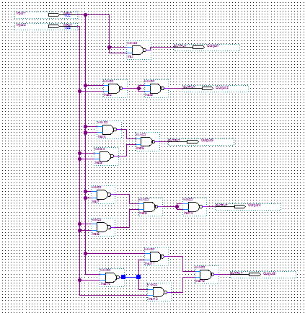

**WAVE FORM:**

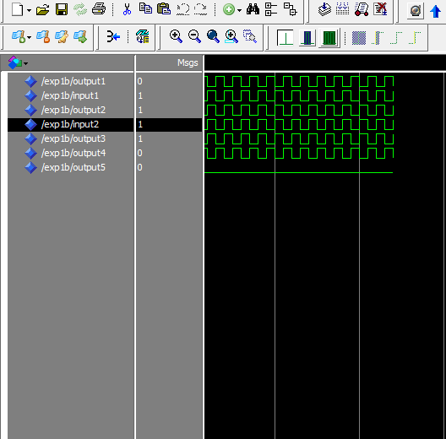

1. **NOR LOGIC**
2. **NOT Gate**

**Truth Table:**

|  |  |
| --- | --- |
| **Input 1** | **Output 1** |
| 0 | 1 |
| 1 | 0 |

1. **AND Gate**

**Truth Table:**

|  |  |  |
| --- | --- | --- |
| **Input 1** | **Input 2** | **Output 2** |
| 0 | 0 | 0 |
| 0 | 1 | 0 |
| 1 | 0 | 0 |
| 1 | 1 | 1 |

1. **OR Gate**

**Truth Table:**

|  |  |  |
| --- | --- | --- |
| **Input 1** | **Input 2** | **Output 3** |
| 0 | 0 | 0 |
| 0 | 1 | 1 |
| 1 | 0 | 1 |
| 1 | 1 | 1 |

1. **NOR Gate**

**Truth Table:**

|  |  |  |
| --- | --- | --- |
| **Input 1** | **Input 2** | **Output 4** |
| 0 | 0 | 1 |
| 0 | 1 | 0 |
| 1 | 0 | 0 |
| 1 | 1 | 0 |

1. **XOR Gate**

**Truth Table:**

|  |  |  |
| --- | --- | --- |
| **Input 1** | **Input 2** | **Output 2** |
| 0 | 0 | 0 |
| 0 | 1 | 1 |
| 1 | 0 | 1 |
| 1 | 1 | 0 |

**CIRCUIT DIAGRAM:**

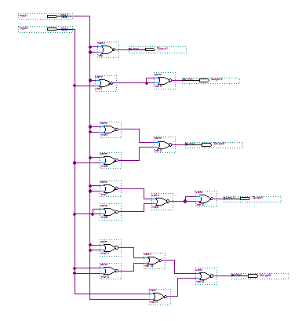

**WAVE FORM:**

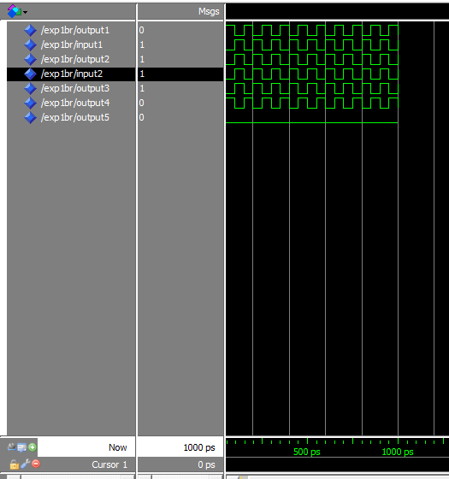

**Aim** – To prove the laws of Boolean Algebra

1. **De-Morgan’s Law**

**TRUTH TABLE:**

**CIRCUIT DIAGRM:**

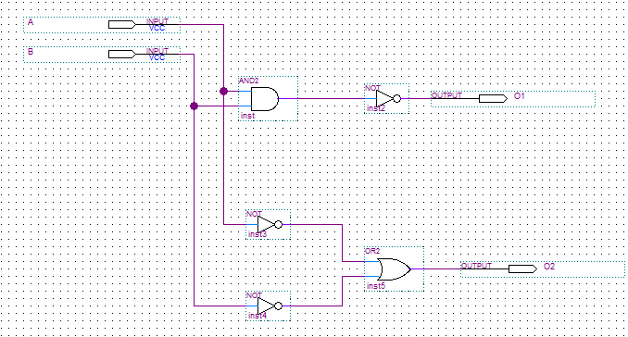

**WAVE FORM:**

